# **Section 1.2: Research PUG Template Engines (cont.)**

## **How to convert pug to html with normal command**

First of all, we need to install NodeJS to be able to run the npm commands on the terminal.

Like most tools today, Pug is a node package that can be easily installed on our system using the following npm command:

**Command: npm install pug –g**

To start pug code we need to use terminal to type **touch index.pug** command or we can create as usual

To compile this file to HTML we open a terminal and navigate to the directory containing the Pug file and run the following command:

**Command: pug index.pug**

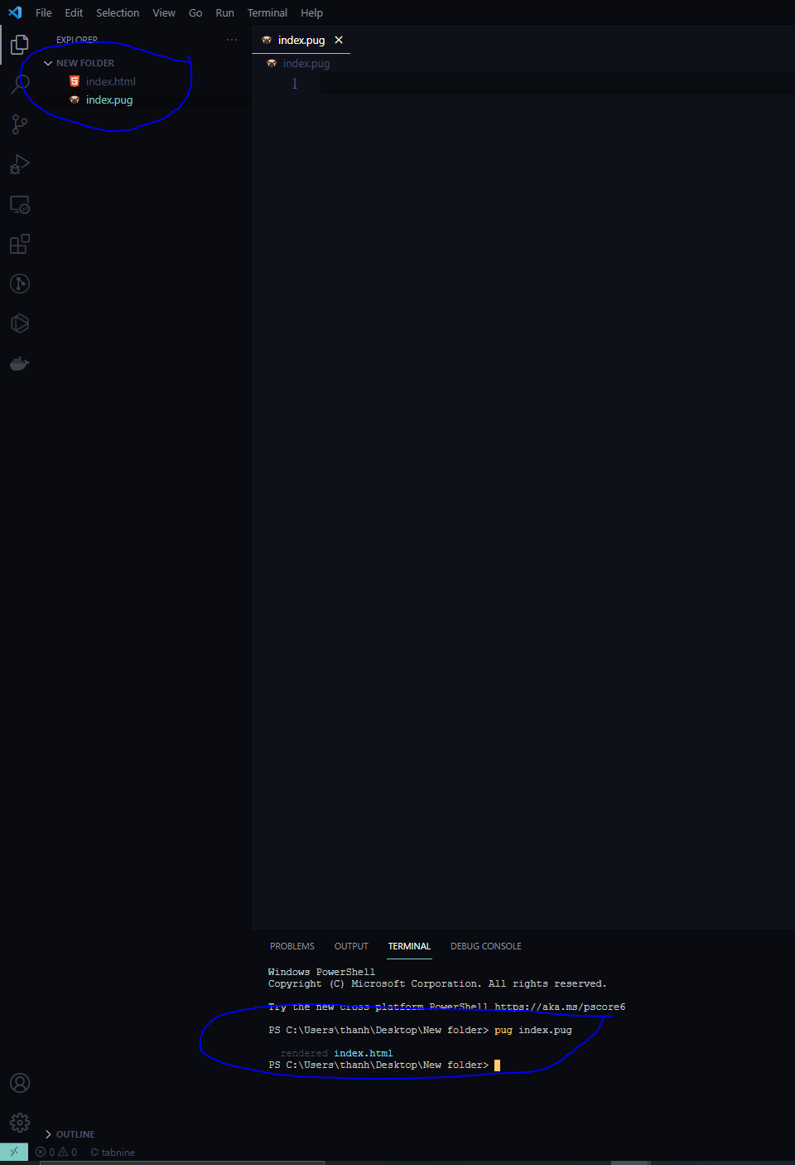

After typing this command, it will automatically create a file named index.html as shown above.

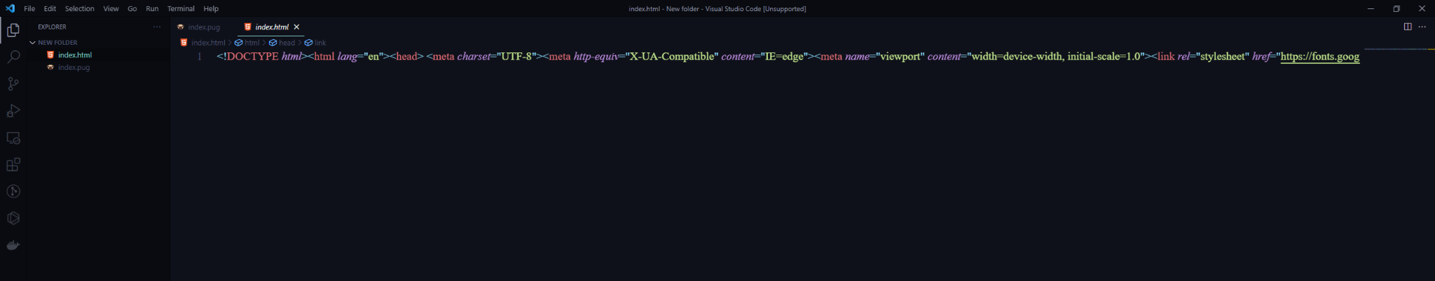

Here are some commands to help format code and automatically compile when the user saves on the pug file. Because now if we use the above compile command, we can see that the HTML file is not formatted and every time we want to compile, we have to enter the pug index.pug command. It is very time consuming.

**Command 1: pug filename.pug -P**

**Command 2: pug -w . -o ./ -P**

## **How to convert pug to html with gulpjs**

This is one of the ways that developers often use in their work every day and this is also the most popular way. You need to use commands to install gulp

**Command 1: npm install gulp --save-dev**

**Command 2: npm install gulp-pug --save-dev**

After finishing the initialization of the Gulpfile.js file, we will start creating a directory under the src/pug path and create an index.pug file to run the test with gulp . Inside the index.pug file we will create a simple structure to facilitate the test converting pug into html.

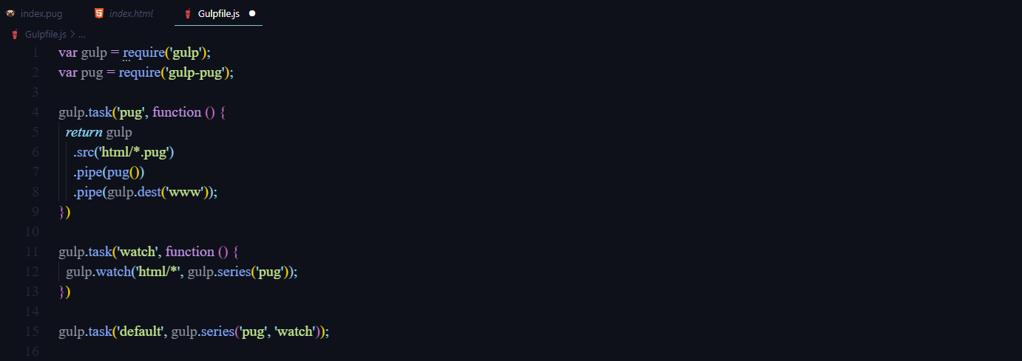

## **How to convert pug to html with extension**

This is a popular extension and is used by many people in converting pug to html

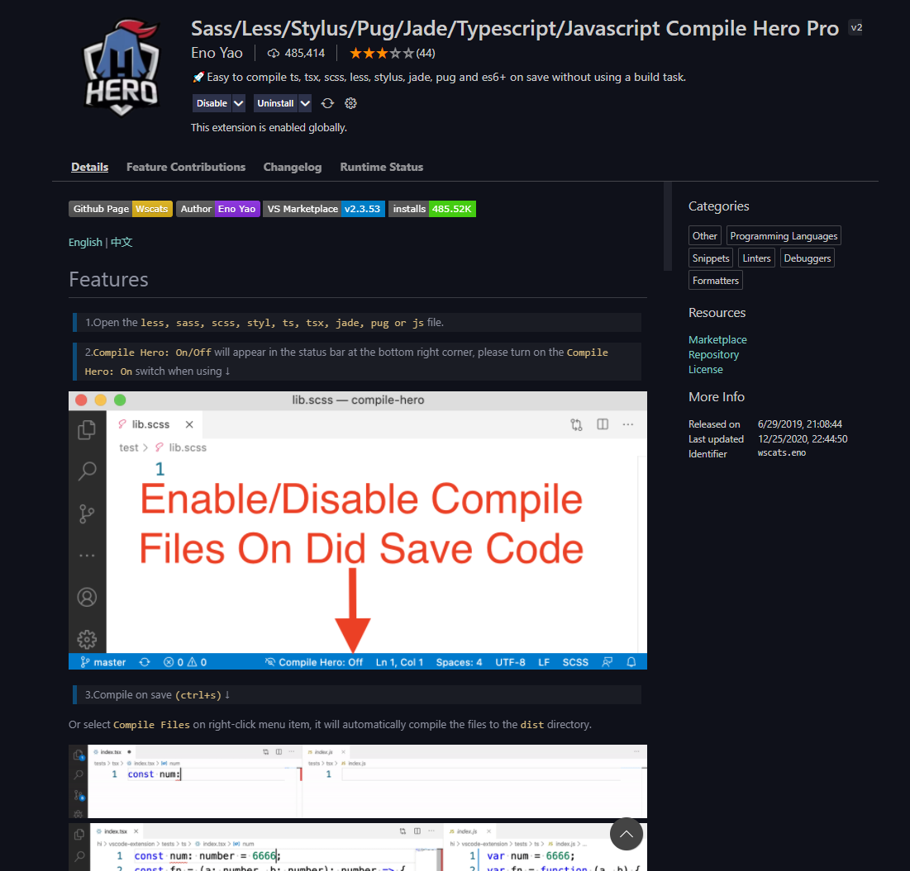

Just activate Compile Hero and after modifying the structure of the .pug file and saving it, Compile Hero will convert it for us with the dist/*.html path.

